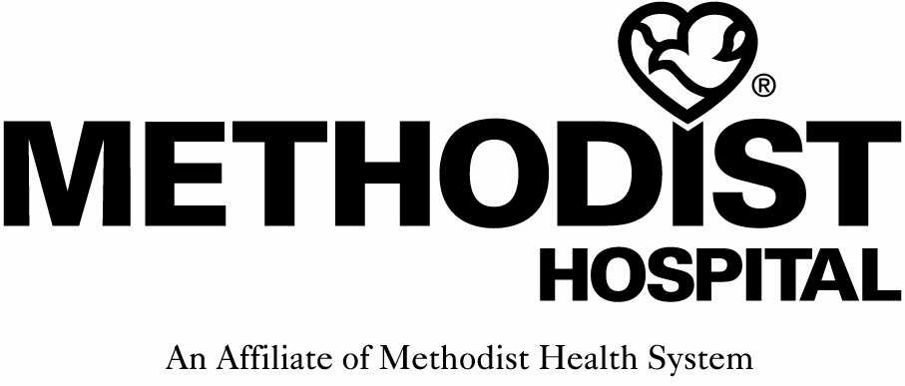
THE NEBRASKA METHODIST HOSPITAL 8303 DODGE STREET OMAHA, NEBRASKA 68114 402-354-4000
Institutional Review Board Request for Review
of Investigational Study
Use of Form: This form is to be used by the principal investigator to request initial review and approval of a proposed study involving human subjects. This form may also be used to submit a Quality Improvement or Evidence Based Practice Project. This form should not be used for annual or other periodic status reports of previously approved studies, unless approval for a modification is requested. This form must be completed, with attachments, and submitted to the Medical Staff Manager or through the Nursing and Allied Health IRB submission process.

1. Title of Study:

2. Date of this Request:

- Medical Staff Department:
(Only if medical staff department is involved and you need to obtain letter of support)

- Principal Investigator's Name:
Office/Organization Address:
Office Phone:
Email address:
Where you work/unit/role:

5. Secondary Investigator(s):
Office/Organization Address:
Office Phone:
Email address:

- Sponsor/Manufacturer Name:
(Only if industry sponsored study)
Address:
Contact Person:
Telephone:

- Reason for Request (Check All Which Apply):

- Federally Sponsored Human Research Intraocular Lens Classified Investigational by FDA
- Investigational Drug Under FDA Supervision IRB Review Required by Sponsor/Manufacturer
- Investigational Device Under FDA Supervision Modification of Previously Approved Study
- Other – necessary for student/employee projects(Explain): _

- Study Will Be Conducted:
- Wholly or Partially at Methodist Hospital Entirely Off Methodist Hospital Campus

- Check All Special/Vulnerable Groups Within Subject Population: □ None

- Children (Ages: ) Physically Disabled
- Pregnant Women Mentally/Emotionally Disabled
- Fetuses Other (Describe:
Please provide summary statements addressing the following points. Although this information may be contained in the other documents you submit, your summaries here will help assure prompt and informed IRB action. If you are seeking only to modify a previously approved study, you may simply describe the changes (or "no change") in each category.

10. Nature and Purpose of the Study: (be specific and explain what the project is, how you will implement it and data analysis and references)

11. Characteristics of Subject Population (Number, Age Ranges (must be 19 or older), Gender, Ethnic Background, and Health Status; Criteria for Inclusion and Exclusion, and Justification for the Utilization of Any Special/Vulnerable Groups):

12. Method of Subject Selection (Methods to be Employed in the Identification/Recruitment of Potential Subjects):

13. Risks to the Subjects (Potential Risks; Probability, Severity, Potential Duration and Reversibility of Such Risks):

- Protection Against Risks (Procedures to be Utilized to Prevent/Minimize Any Potential Risks):

- Benefits (Potential Benefits To Be Gained By the Subject as Well as Benefits That May Accrue to Medical Science or Society in General):

There are no known benefits to the subjects. However, _____________

- Risk-Benefit Analysis (Why the Risks to the Subject are Reasonable in Relation to the Anticipated benefits to the Subject and/or in Relation to the Importance of the Knowledge that May Reasonably be Expected to Result):
See above.

17. Therapeutic Alternatives (Therapeutic Alternatives That May Be Advantageous to the Subject):
(Include subjects have a choice in whether to participate; standard of care will be provided along with the study intervention as applicable).

- Informed Consent: Please describe the process by which you will obtain the informed consent of each study subject, addressing (i) – (vii).
- Only research studies may request a waiver of consent. If requesting one, complete the Institutional Review Board Request for Waiver of Consent and/or HIPAA Authorization Form #6 in Methodist IRB Handbook.

- Evidence Based Practice and Quality Improvement studies are not deemed Human Subject Research as defined by Common Law. Therefore a waiver of consent is not applicable.

- If using a survey in any study where informed consent is not signed, include in the instructions to subjects, “that by completing the survey it implies the subject gives permission to participate”. This can be included in the recruitment email or letter in which the survey link is included.

Complete the next questions if an informed consent is included in the study.

- who conducts the main consent discussion with the subject

- when this discussion takes place

- who is present at this discussion and what materials are presented to the subject

- when the subject is asked to sign the consent document

- whether the subject is provided a copy of the consent document

- whether you anticipate ever enrolling a subject with surrogate consent because the subject is not competent to consent for himself or herself, and

- any circumstances under which you might enroll a subject without informed consent

- Documentation: The following documents are submitted with this Request for Review (If No, explain why not and where/when the document(s) will be available):
- Yes No Complete Investigational Plan and Protocol (industry sponsored)
- Yes No Report of Prior Investigations
- Yes No Patient Informed Consent Form
- Yes No Reporting Forms That the Sponsor Requires from IRB (industry sponsored)
- Yes No Medical Staff Department Recommendation – if needed
- Yes No (Secondary Investigations): Certification of Review and Approval by the Primary IRB
- Yes No Other (List all appendixes) ___________________________________________
_________________________________________________________________
- Financial Considerations:
- Do you or any other local investigators have any financial or management interest in the sponsor or manufacturer, direct or indirect, in any form? No Yes, as Follows:

- Will there be any payments from the study sponsor, study group or other interested party to you, your staff or your institution in connection with this study, whether designated for fees, expenses, or otherwise?
No Yes, As Follows (Please provide an itemization of all anticipated payments, and how they will be used or applied. A study budget should be provided if available):

- Will there be any costs or charges to the patients in this study, beyond what they would incur from standard or alternative therapies? No Yes, as Follows (Including Expected Source of Payment):
21. Research/Investigator Status:
- Has the proposed study, or any substantially similar study, previously been denied approval or had its approval suspended or revoked by this IRB or any other IRB? No Yes (explain):

- Have you (or to the best of your knowledge, any secondary investigator) ever been subject to any of the following (or is any formal investigation or other formal action pending which could lead to such a result):
- Revocation of approval to serve as an investigator in a research study, imposed by any IRB, sponsor or other entity? No Yes (explain):

- Debarment as a government contractor, or disqualification from any government or private grants or research programs? No Yes (explain):

- Criminal prosecution or civil lawsuit seeking criminal penalties, injunction or damages arising out of clinical research involving human subjects? No Yes (explain):

- Do you agree to notify the IRB chair if events occur which would change any of your answers to the preceding questions? No Yes
- Have you received, and do you agree to review, understand and be bound by, this IRB Handbook? No Yes

Investigator's Certification: I certify that the foregoing is complete and accurate to the best of my knowledge. I will advise the Chair of the IRB of any significant changes of which I become aware. I have received, read and understand the Handbook for IRB Members and Investigators, including the Statement of Ethical Principles and Policy, and agree to comply with all of the terms, conditions and standards contained within the Handbook, with all periodic reporting requirements, and with all applicable laws and regulations.

Signature of Principal Investigator:

Date Submitted:

****Please note: The Methodist Hospital IRB Guidelines require a one-time fee of $2000.00 for submission
of new protocols. This fee applies to industry-sponsored studies, not nonprofit cooperative research group
trials or local physician-investigators. The fee is due upon submission of the Request for Review.

