

SURGICAL FIRE PROCEDURES

Jennie Edmundson Memorial Hospital
933 E. Pierce Street
Council Bluffs, IA 51503

Created: January 2022
Reviewed: August 2023
Revised: August 2022

This document is copyrighted unto the laws of the United States. Unauthorized use, duplication, or reproduction, including the use of electronic means, is prohibited by law without the express permission of Jensen Hughes.

© Jensen Hughes – 2023
INDEX

USING A PORTABLE FIRE EXTINGUISHER 3

DEPARTMENTAL PROCEDURES

Labor & Delivery: C-Section Room (5th Floor) 5
Evacuation Protocol 6
Charge Nurse 10
Fire Evacuation Floor Plan 12

PACU 13
Medical Equipment Breakdown Procedures 15
Charge Nurse 17
Fire Evacuation Floor Plan 18

Sterile Processing 19
Fire Evacuation Floor Plan 20

Surgery 21
Evacuation Protocol 22
Charge Nurse 26
Fire Evacuation Floor Plan 27

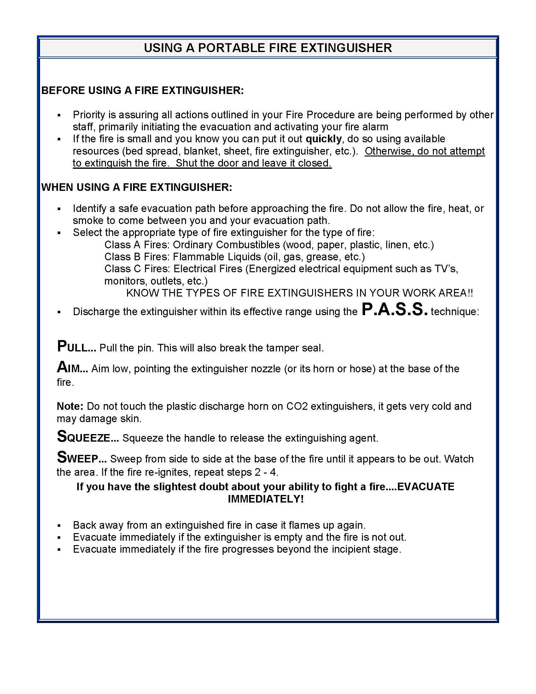

DEPARTMENTAL FIRE PROCEDURES

DEPARTMENTAL FIRE PROCEDURES

LABOR & DELIVERY – C-SECTION ROOM (5th FLOOR)

Refer also to the hospital’s General Fire Safety Plan.

I... IF YOU DISCOVER A FIRE:

R. Remove anyone in room while calling out, “FIRE, location...” for assistance. Close door to fire room.
NOTE: In event of fire in C-Section Room:
  - Room intercom can be used to notify others outside room.
  - After hours and on weekends, use room phone or portable phone to make overhead page of fire location.
  - Extinguish fire if on or in patient, using protocol in Section IV of this plan.
  - Evacuate patient from involved C-Section Room per protocol below, at direction of Surgeon.

A. Activate fire alarm; make overhead announcement of fire location by dialing “6-6911.”
NOTES:
- In event of fire in a C-Section Room, this is responsibility of any staff member at OR Surgical Desk, or anyone hearing “FIRE” being called out.
- If Surgical Team does not hear alarm after evacuation of involved room, one of the team is to go to the nearest pull station to activate fire alarm.

C. Close all remaining doors in fire zone; place patients into rooms.

E. Evacuate if directed to do so by person in charge.

NOTES:
- If the fire is small and you know you can put it out quickly, do so using available resources (saline, surgical towel, sheet, fire extinguisher, etc.). Otherwise, do not attempt to extinguish the fire. Shut the door and leave it closed.

In event of fire involving patient in surgical suite, all medical gas delivery to patient must be terminated as fire is being extinguished.

- Oxygen shutdown to an area is responsibility of Charge Nurse in area.

Upon evacuation of surgical suite, shutdown of medical gases to suite being evacuated will be done at direction of Anesthesia Provider.

- Order of the above steps is somewhat flexible. However, the evacuation of the room’s occupant(s) and confinement of the fire shall be the top priorities.

Continued: Labor & Delivery – C-Section Room (5th Floor)

II... EVACUATION SITE: Mother / Baby Unit
EVACUATION PROTOCOL
Patient to be moved on OR table.

Scrub Person:
- Assist Surgeon in covering surgical site (i.e., saline-soaked towel, lap sponges), as directed.
- Remove necessary instruments, sponges and suture material from back table / mayo stand and place (placed in a basin / wrapped in a surgical towel from mayo stand) on patient.
  - If baby is not yet out, take instruments on back table to evacuation site, if necessary.
- Assist in moving OR table, unless taking instruments on back table.

Circulator:
- Announce, “FIRE, location...” and ensure fire alarm is activated.
- Move equipment and cords away to clear path from OR table to door.
- Assist Anesthesia Provider with breakdown of patient from anesthesia machine (disconnect monitor leads, blood pressure cuff, etc.).
- Obtain bag valve mask, if necessary.
- Take patient’s medical record / chart, if possible (delegate, as necessary).
- Assist in moving OR table.

Anesthesia Provider:
- Remove IV bags from poles and place on table with patient.
- Disconnect monitor leads, blood pressure cuff, etc. from patient.
- Gather airway supplies and drugs to maintain patient in anesthetized state.
- Bring table to “unlock” position using hand controls or emergency release.
- Shut off anesthesia machine (be sure gas flow is shut off), disconnect line from patient and use bag valve mask to ventilate patient.
- If possible and safe to do so, assign staff member to move anesthesia machine to evacuation site.

Surgeon:
- Stabilize patient and prepare surgical site for transport.
- Give final direction to move and assist in movement of OR table.

OB Nurse:
- If baby is not out:
  - OB Nurse shall take isolette to evacuation site.
  - Direct patient’s support person to assist in moving OR table.
- If baby is out:
  - Take baby and patient’s support person to evacuation site.
Continued: Labor & Delivery – C-Section Room (5th Floor)

Surgical Aide outside suite:
- Clear path in corridor from Surgery to Mother / Baby Unit.
- Open doors for evacuating team.
- Assist, as necessary.

NOTES FOR ANESTHESIA PROVIDER:
- When disconnecting anesthesia machine from patient, the Anesthesia Provider shall shut off anesthesia machine, thus stopping flow of gases into the room. Upon evacuation of surgical suite, Anesthesia Provider shall instruct staff members to shut off medical gas valves (oxygen, nitrous, etc.) controlling supply to the evacuated suite, if possible. Medical gas valves for this are located outside each C-Section OR.

2. Once patient has been disconnected from anesthesia machine, ventilation will be maintained with bag valve mask using room air until clear of fire area, and then connected to an oxygen source, as necessary. If patient cannot be reconnected to anesthesia machine, drugs will be used to maintain patient in anesthetized state (as necessary) once patient is at evacuation site.

AREA EVACUATION:
Decision to evacuate remaining suites in surgical area will be made by nurse in charge of C-Section ORs area, using the following guidelines:

- If fire has been extinguished, no further evacuation may be necessary, based on the conditions of the room. Instruct other suites to remain.

- If fire has not been extinguished and corridor conditions are tolerable, consider evacuation of remaining rooms in smoke compartment. However, potential impact on patient must be weighed before making final decision.

- If corridor smoke conditions would not be tolerable for patients, do not evacuate. Instruct other suites to remain.

NOTES FOR NURSE IN CHARGE OF C-SECTION AREA:
- Bring / designate staff member to bring phone list for C-Section area, as well as Schedule and Add-on List, to evacuation site.

- Upon arrival at evacuation site, verify all patients and staff are accounted for and be prepared to report results to Control Station.

C-Section Waiting Area
Visitors in Waiting or other open areas will be escorted by reception staff to a safe location in hospital. Reception staff will account for all Waiting Area occupants and ask them to remain in safe area until an “All Clear” has been announced or they are further directed by staff or firefighters.
Continued: Labor & Delivery – C-Section Room (5th Floor)

EQUIPMENT TO BE TAKEN TO EVACUATION SITE, IF POSSIBLE:
- Adult crash cart
- Fetal monitors
- Med cart or med tray drawer from cart
- Newborn stabilization cart
- Panda
- Photo therapy (Bili-lights)
- Pulse oximeter

III… IF ALARM SOUNDS FROM ELSEWHERE IN BUILDING:

- Remain in your assigned area and await further instructions. If not in assigned area, report back.
- Close doors in area.
- If possible, no new cases should begin until an “All Clear” has been announced or otherwise instructed. Cases already in progress will continue until otherwise instructed.
- Person in charge of area shall account for all patients and staff and be prepared to report results to Control Station.

IV… FIRE SUPPRESSION ON OR IN PATIENT:

ALL fire suppression on or in patient will involve turning OFF oxygen or other medical gases as an immediate first step.

Extinguishment of fire shall only be attempted by staff of immediate area and should be accomplished quickly with a nearby object (saline / water, towel, sheet, fire extinguisher, etc.).

- DO NOT USE ALCOHOL-BASED SOLUTIONS TO EXTINGUISH ANY FIRE.

- DO NOT USE ANY LIQUID FOR FIRES ON OR IN ENERGIZED ELECTRICAL EQUIPMENT (laser, ESU / Bovie, anesthesia machine, etc.).

AIRWAY – ENDOTRACHEAL TUBE [ET] / LARYNGEAL MASK AIRWAY [LMA]:
- Turn off medical gases.
- Disconnect breathing circuit.
- Extubate patient and douse any remaining fire / embers by placing ET Tube / LMA in bowl of saline, if necessary.
- Treat patient (sample steps below – may involve scoping patient).
  - Per ECRI / Anesthesia Patient Safety Foundation guidelines, consider pouring saline into throat to cool and irrigate, as necessary.
Continued: Labor & Delivery – C-Section Room (5th Floor)

  - Re-establish airway.
  - Ventilate with air, then gradually increase oxygen.

* Steps may occur simultaneously, but NEVER extubate before disconnecting breathing circuit.

ORAL CAVITY (Tonsil sponge, etc.): Steps may occur simultaneously
- Turn off medical gases.
- Disconnect breathing circuit (if applicable).
- Deliver saline into mouth from bulb or delivery syringe until flame is extinguished.
- Extubate patient and douse ET Tube in bowl of saline (if necessary).
- Treat patient (sample steps below – may involve scoping patient).
  - Re-establish airway.
  - Ventilate with air, then gradually increase oxygen.

SURGICAL SITE / SKIN / HAIR / SPONGES: Steps may occur simultaneously
    - Turn off medical gases.
    - Douse area with saline from bowl on back table / mayo stand.
    - Remove any surgical drapes from area to ensure flame is extinguished.
    - If flame is not extinguished, use smothering technique (surgical towel, etc.) or more saline. If using blanket or towel to suppress fire, ensure oxygen is off and all sharp instruments have been removed from patient to avoid additional injury.
    - Treat patient.

SURGICAL DRAPES: Steps may occur simultaneously
- Turn off medical gases.
- Attempt to pull surgical drapes to ground and extinguish flame on ground.
- If unable to quickly remove drapes, use smothering technique. Ensure all sharp instruments have been removed from patient to avoid additional injury.
- If flame is not extinguished, douse area with saline from bowl.
- Remove any surgical drapes from area to ensure flame is extinguished.
- Treat patient.

Deionized water mist fire extinguishers are available in ORs as last resort for fire on or in patients.

LABOR & DELIVERY CHARGE NURSE

I… IF FIRE IS ON YOUR UNIT:

- Respond immediately to fire location and ensure:
    - Fire room and adjoining room have been evacuated.
    - Door(s) to fire room have been closed.
    - Fire alarm has been activated and overhead page of fire location has been made.
    - All patients have been removed from corridor; doors have been closed in fire area.
    - All equipment has been removed from hall (not placed in occupied rooms).

  - Make decision regarding further evacuation, using the following guidelines:
    - If fire has been extinguished, no further evacuation is necessary.
- Have staff reassure patients while awaiting arrival of Fire Department.

    - If fire has not been extinguished and corridor conditions are tolerable, begin evacuation as follows:
- Move patients from fire area as follows:
- C-Section Room evacuates to Mother / Baby Unit.
- Have staff evacuate rooms adjacent to fire room first, followed by room opposite the fire room. Remaining rooms in compartment shall then be evacuated.
- If room has been evacuated, place or tie glove on door handle to indicate an evacuated room.
- Direct removal of patients’ charts to evacuation site.
- Account for patients and staff once all are relocated. Be prepared to report results to Control Station.

    - If corridor smoke conditions would not be tolerable for patients, do not evacuate.
- Inform Fire Department of smoke concerns upon arrival.

II… IF ALARM SOUNDS FROM ELSEWHERE IN BUILDING:

  - Direct remaining staff in securing unit by moving patients into rooms, closing doors, clearing corridors, etc.
  - Once unit is secured, direct staff to make rapid rounds, checking on and reassuring patients.
  - Position one staff member at unit entrance to direct staff arriving with evacuated patients to appropriate area(s) of receiving unit.
Continued: Labor & Delivery Charge Nurse

  - Ensure initial care of patients evacuated to your area, if applicable.
  - Account for all patients and staff in your area. Be prepared to report results to Control Station.
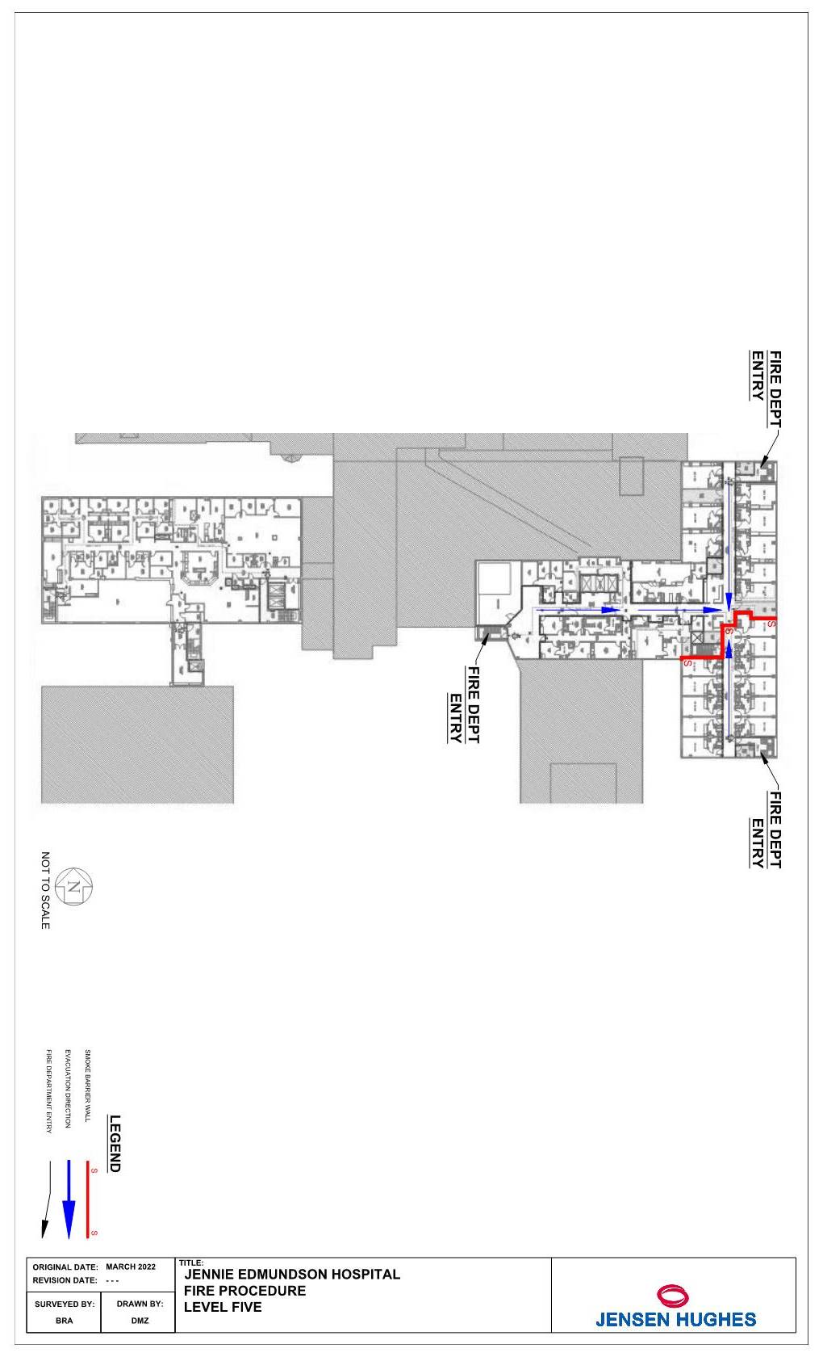
DEPARTMENTAL FIRE PROCEDURES
PACU

Refer also to the hospital’s General Fire Safety Plan.

I… IF YOU DISCOVER A FIRE:

R. Remove anyone in room while calling out, “FIRE, location...” for assistance. Close door to fire room.

A. Activate fire alarm; make overhead announcement of fire location by dialing “6-6911.”

C. Close all remaining doors in fire zone; place patients into rooms.

E. Evacuate if directed to do so by person in charge of area.

NOTES:
- In rare situations, it may be appropriate to attempt to extinguish a fire while the room is occupied, if the room cannot be immediately evacuated. (The inability to quickly evacuate a bariatric or high-acuity patient from fire room is an example.)

- If the fire is small and you know you can put it out quickly, do so using available resources (blanket, sheet, fire extinguisher, etc.). Otherwise, do not attempt to extinguish the fire. Shut the door and leave it closed.

- Oxygen shutdown is responsibility of responding Respiratory Therapist, Charge Nurse or Anesthesia Provider of area.

- Order of the above steps is somewhat flexible. However, the evacuation of the room’s occupant(s) and confinement of the fire shall be the top priorities.

II… EVACUATION SITE: Surgery Department

NOTES:
- Responding staff will receive patients from department staff and complete transfer while maintaining life support, as necessary. This will allow department staff to concentrate on patients and equipment breakdown.

- Upon arrival at evacuation site, person in charge of department shall verify all patients and staff are accounted for and be prepared to report results to Hospital Command Center.

Continued: PACU

- Visitors in Waiting or other open areas will be escorted by reception staff to a safe location in hospital. Reception staff will account for all Waiting Area occupants and ask them to remain in safe area until an “All Clear” has been announced or they are further directed by staff or firefighters.

- Patients will be evacuated on stretchers, in wheelchairs or ambulated, as necessary.

**SEE MEDICAL EQUIPMENT BREAKDOWN PROCEDURES – p. 15.**

EQUIPMENT TO BE TAKEN TO EVACUATION SITE, IF POSSIBLE:
- Crash cart
- Portable monitors
- Spare oxygen cylinders

III… IF ALARM SOUNDS FROM ELSEWHERE IN BUILDING:

  - Remain in your assigned area and await further instructions. If not in assigned area, remain on floor / in area until an “ALL CLEAR” has been announced or you are directed back to your assigned unit.
  - Close doors in area, shut down equipment and clear area of equipment.
  - Prepare to receive evacuated patients if alarm activation is from area that evacuates to your area.
  - Person in charge of department shall account for all staff and be prepared to report results to Hospital Command Center.

NOTES RELATING TO VISITORS
- Visitors in Waiting or other open areas will be escorted to a safe area by department staff and asked to remain there until an “All Clear” has been announced or they are further directed by staff or firefighters.
- Visitors in public areas will be asked to remain there until an “All Clear” has been announced or they are further directed by staff or firefighters.

- Visitors with patients will be asked to remain with them until an “All Clear” has been announced or they are further directed by staff or firefighters.

MEDICAL EQUIPMENT BREAKDOWN PROCEDURES
PACU

Refer also to the hospital’s General Fire Safety Plan.

Bair Hugger:
- Disconnect hose from blanket.

Cardiac Monitors:
- Unplug cable / cartridge from monitor.
OR
- Disconnect cable from monitor leads.

Catheter Drainage Bag:
- Place drainage bag on patient.
- Option: Disconnect catheter from drainage tubing.

Feeding Pump Assembly:
- Remove tubing from pump. Remove bag from pole and place next to patient.
- Option: Disconnect feeding line from NG-tube or G-tube.

IV:
- Clamp line or leave open (at discretion of Nurse). Remove bag from pole and place on bed.

IV with Pump:
If pump is not needed:
Remove IV tubing from pump. Remove bag from pole and place on bed.

If pump must be taken:
- Option 1: Disconnect pump from electrical outlet, remove pump and bag
from pole and place on bed.
- Option 2: Disconnect pump from electrical outlet and move pole with bed.

Oxygen:
- Shut off flowmeter and remove mask or cannula from patient.
- Option: Remove line from flowmeter after shutting off.
OR
- Disconnect flowmeter from wall outlet and take with patient.

PCA Pump:
- Disconnect line leading from PCA to IV line.
OR
- Unplug pump from electrical outlet and move pole with bed.

Portable Cardiac Monitor / Pacer / Defibrillator:
- Unplug unit from electrical outlet and place with patient.

Pressure Monitoring Systems:
- Disconnect lead from monitor. Lay bag, pressure cuff and transducer on bed.
- Option: Shut line at stopcock and disconnect.

NOTE: Follow same procedure for temporary pacemaker and Swan-Ganz type catheters.

Pulse Oximeter:
- Disconnect from electrical outlet and place on bed.
OR
- Remove from patient's finger.

Suction:
- Disconnect line from top of suction canister.

Syringe Pump:
- Disconnect from electrical outlet. Remove from stand and place on bed.

NON-BATTERY-POWERED UNITS: If dosage is critical, Nurse will have to manually operate as best as possible.

Warming / Cooling Blanket:
- Clamp and disconnect tubing at junction block.
PACU CHARGE NURSE

I… IF FIRE IS ON YOUR UNIT:

  - Report immediately to fire location and ensure:
    - Patients in immediate danger have been evacuated.
    - Door(s) to fire room have been closed and marked.
    - Fire alarm has been activated and call has been placed to Security.

  - Make decision regarding further evacuation, using the following guidelines:
    - If fire has been extinguished, no further evacuation is necessary.
- Have staff reassure patients while awaiting arrival of Fire Department.

- If fire has not been extinguished in either PACU, evacuate patients from affected area(s) to evacuation site.
- Direct removal of patients’ charts to evacuation site.

- Account for patients and staff once all are relocated. Be prepared to report results to Hospital Command Center.

II… IF ALARM SOUNDS FROM ELSEWHERE IN BUILDING:

  - Direct appropriate staff to report to fire area, as appropriate.

  - Direct remaining staff in securing unit by moving patients into rooms, closing doors, clearing corridors, etc.

  - Once unit is secured, direct staff to make rapid rounds, checking on and reassuring patients.

  - If alarm activation is from area that evacuates to your department, prepare / direct staff in preparing to receive patients by clearing space.

  - Position one staff member at unit entrance to direct staff arriving with evacuated patients to appropriate area(s) of receiving unit.

  - Ensure initial care of patients evacuated to your area, if applicable.

  - Account for all patients and staff in your area. Be prepared to report results to Hospital Command Center.
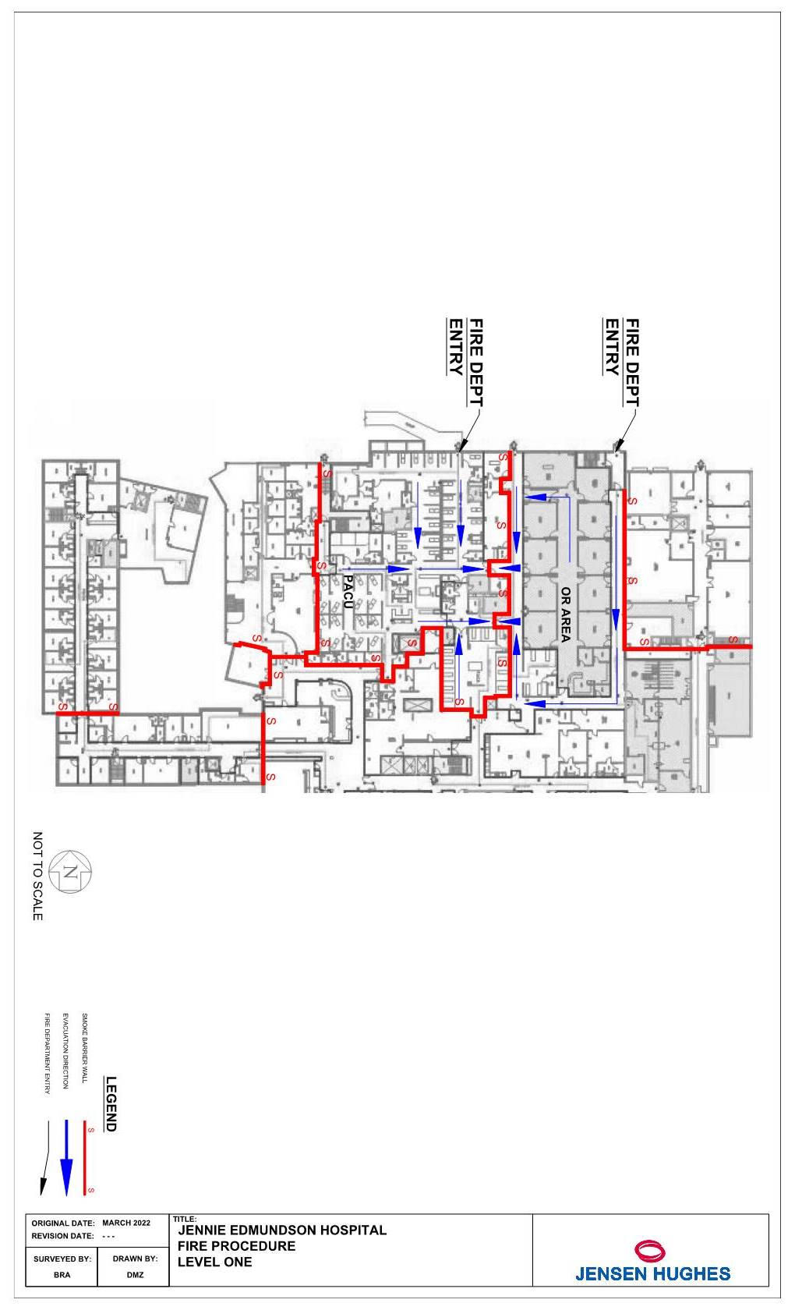
DEPARTMENTAL FIRE PROCEDURES
STERILE PROCESSING

Refer also to the hospital’s General Fire Safety Plan.

I... IF YOU DISCOVER A FIRE IN YOUR AREA:

R. Remove anyone in room while calling out, “FIRE, location...” for assistance. Close door to fire room and any room connecting doors.

A. Activate fire alarm and make overhead announcement of fire location by dialing “6-6911.”

C. Close all remaining doors in fire zone; place patients into rooms.

E. Evacuate remaining rooms in smoke compartment, if directed to do so by person in charge.

NOTES:
      - In rare situations, it may be appropriate to attempt to extinguish a fire while the room is occupied, if the room cannot be immediately evacuated. (The inability to quickly evacuate a bariatric or high-acuity patient from fire room is an example.)

      - If the fire is small and you know you can put it out quickly, do so using available resources (blanket, sheet, fire extinguisher, etc.). Otherwise, do not attempt to extinguish the fire. Shut the door and leave it closed.

      - Oxygen shutdown is responsibility of responding Respiratory Therapist, Charge Nurse or Anesthesia Provider of area.

      - Order of the above steps is somewhat flexible. However, the evacuation of the room’s occupant(s) and confinement of the fire shall be the top priorities.

II... EVACUATION SITE: PACU

Upon arrival at evacuation site, person in charge of department shall verify all staff are accounted for and be prepared to report results to Control Station.

III... IF ALARM SOUNDS FROM ELSEWHERE IN BUILDING:

  - Remain in your assigned area and await further instructions. If not in assigned area, report back.
  - Close doors in your smoke compartment.
  - Person in charge of department shall account for all staff and be prepared to report results to Control Station.
DEPARTMENTAL FIRE PROCEDURES

SURGERY

Refer also to the hospital’s General Fire Safety Plan.

I... IF YOU DISCOVER A FIRE:

R. Remove anyone in room while calling out, “FIRE, location...” for assistance. Close door to fire room.
NOTE: In event of fire in a surgical suite:
  - Room intercom or portable phone can be used to notify others outside room at Surgery Front Desk.
  - After hours and on weekends, use room phone or portable phone to make overhead page of fire location (6-6911).
  - Extinguish fire if on or in patient, using protocol in Section IV of this plan.
  - Evacuate patient from involved OR suite per protocol below, at direction of Surgeon.

A. Activate fire alarm and make overhead announcement of fire location by dialing “6-6911.”
NOTES:
- In event of fire in a surgical suite, this is responsibility of any staff member at Surgery Desk or anyone hearing “FIRE” being called out.
- If Surgical Team does not hear alarm after evacuation of involved room, one of the team shall go to nearest pull station to activate fire alarm.

C. Close all remaining doors in fire zone; place patients into rooms.

E. Evacuate if directed to do so by person in charge.

NOTES:
- If the fire is small and you know you can put it out quickly, do so using available resources (saline, surgical towel, sheet, fire extinguisher, etc.). Otherwise, do not attempt to extinguish the fire. Shut the door and leave it closed.

In event of fire involving patient in surgical suite, all medical gas delivery to patient must be terminated as fire is being extinguished.

- Oxygen shutdown to an area is responsibility of Charge Nurse in area.

Upon evacuation of surgical suite, shutdown of medical gases to suite being evacuated will be done at direction of Anesthesia Provider.

- Order of the above steps is somewhat flexible. However, the evacuation of the room’s occupant(s) and confinement of the fire shall be the top priorities.
Continued: Surgery

II... EVACUATION SITE: PACU

EVACUATION PROTOCOL
Patient to be moved on OR table.
Exception – Patient from Cysto Room to be transferred to gurney.

Scrub Person:
- Assist Surgeon in covering surgical site (i.e., saline-soaked towel, lap sponges), as directed.
- Remove necessary instruments, sponges and suture material from back table / mayo stand and place (placed in a basin / wrapped in a surgical towel from mayo stand) on patient.
- Assist in moving OR table.

Circulator:
- Announce, “FIRE, location...” and ensure fire alarm is activated.
- Move equipment and cords away to clear path from OR table to door.
- Assist Anesthesia Provider with breakdown of patient from anesthesia machine (disconnect monitor leads, blood pressure cuff, etc.).
- Obtain bag valve mask and oxygen cylinder, if necessary.
- Take patient’s medical record / chart, if possible (delegate, as necessary).
- Assist in moving OR table.

Anesthesia Provider:
- Remove IV bags from poles and place on table with patient.
- Disconnect monitor leads, blood pressure cuff, etc. from patient.
- Gather airway supplies and drugs to maintain patient in anesthetized state.
- Bring table to “unlock” position using hand controls or emergency release.
- Shut off anesthesia machine (be sure gas flow is shut off), disconnect line from patient and use bag valve mask to ventilate patient.
- Upon evacuation of surgical suite, assign staff member to shut off medical gases serving the room being evacuated, if possible.
- If possible and safe to do so, assign staff member to move anesthesia machine to evacuation site.

Primary Surgeon:
- Stabilize patient and prepare surgical site for transport.
- Give final direction to move and assist in movement of OR table.

Surgical Aide outside suite:
- Clear path in corridor.
- Open doors for evacuating team.
- Assist, as necessary.

Continued: Surgery

SPINE / ORTHOPEDIC DEVICES (i.e., Mayfield headrest, Jackson table, OSI tables, etc., in addition to above):

- If patient is on Jackson table, care should be taken not to move, unless necessary. If necessary, move patient in prone position to evacuation site.
- Move OR table with positioning / immobilization devices attached, as possible.

ROBOTIC INSTRUMENTS:

Assisting Surgeon:
- Immediately disconnect instruments from robotic arms.

Circulator or Robot Assistant:
- Upon disconnect, drive robot to side of room.
- Position yourself to be ready to lift electrical and monitoring cords from floor to a position where Surgical Team can move underneath cords as they move patient from room.

NOTES FOR ANESTHESIA PROVIDER:
- When disconnecting anesthesia machine from patient, Anesthesia Provider shuts off anesthesia machine, thus stopping flow of gases into room. Upon evacuation of surgical suite, Anesthesia Provider shall instruct staff member to shut off medical gas valves (oxygen, nitrous, etc.) controlling supply to evacuated suite, if possible. Medical gas valves for this are located in hallway outside entrance to each OR.

- Once patient has been disconnected from anesthesia machine, respiration will be maintained with bag valve mask using room air until clear of fire area, then connected to an oxygen source, as necessary. If patient cannot be reconnected to anesthesia machine, drugs will be used to maintain patient in anesthetized state (as necessary) once patient is at evacuation site.

AREA EVACUATION:
Decision to evacuate remaining suites in surgical area will be made by nurse in charge of Surgery area, using the following guidelines:

- If fire has been extinguished, no further evacuation may be necessary, based on the conditions of the room. Instruct other suites to remain.

- If fire has not been extinguished and corridor conditions are tolerable, consider evacuation of remaining rooms in smoke compartment. However, potential impact on patient must be weighed before making final decision. Priority should be given to evacuation of OR suite connected to fire room by sub-sterile area, as appropriate.

- If corridor smoke conditions would not be tolerable for patients, do not evacuate. Instruct other suites to remain.
Continued: Surgery

NOTES FOR NURSE IN CHARGE OF SURGERY AREA:
      - Bring / designate staff member to bring phone list for surgery area, as well as Schedule and Add-on List, to evacuation site.

      - Upon arrival at evacuation site, verify all patients and staff are accounted for and be prepared to report results to Control Station.

Surgery Waiting Room
Visitors in Waiting or other open areas will be escorted by reception staff to a safe location in hospital. Reception staff will account for all Waiting Area occupants and ask them to remain in safe area until an “All Clear” has been announced or they are further directed by staff or firefighters.

EQUIPMENT TO BE TAKEN TO EVACUATION SITE, IF POSSIBLE:
- Portable oxygen cylinders

III… IF ALARM SOUNDS FROM ELSEWHERE IN BUILDING:

- Remain in your assigned area and await further instructions. If not in assigned area, report back.
- Close doors and windows in area.
- No new cases should begin until an “All Clear” has been announced or otherwise instructed. Cases already in progress may continue until otherwise instructed.
  - Prepare to receive evacuated patients if alarm activation is from the following area:
    - PACU
- Person in charge of area shall account for all patients and staff and be prepared to report results to Control Station.

IV… FIRE SUPPRESSION ON OR IN PATIENT:

ALL fire suppression on or in patient will involve turning OFF oxygen or other medical gases as an immediate first step.

Extinguishment of fire shall only be attempted by staff of immediate area and should be accomplished quickly with a nearby object (saline / water, towel, sheet, fire extinguisher, etc.).

- DO NOT USE ALCOHOL-BASED SOLUTIONS TO EXTINGUISH ANY FIRE.

- DO NOT USE ANY LIQUID FOR FIRES ON OR IN ENERGIZED ELECTRICAL EQUIPMENT (laser, ESU / Bovie, anesthesia machine, etc.).

AIRWAY – ENDOTRACHEAL TUBE [ET] / LARYNGEAL MASK AIRWAY [LMA]:
- Turn off medical gases.
Continued: Surgery

- Disconnect breathing circuit.
- Extubate patient and douse any remaining fire / embers by placing ET Tube / LMA in bowl of saline, if necessary.
- Treat patient (sample steps below – may involve scoping patient).
  - Per ECRI / Anesthesia Patient Safety Foundation guidelines, consider pouring saline into throat to cool and irrigate, as necessary.
  - Re-establish airway.
  - Ventilate with air, then gradually increase oxygen.

* Steps may occur simultaneously, but NEVER extubate before disconnecting breathing circuit.

ORAL CAVITY (Tonsil sponge, etc.): Steps may occur simultaneously
- Turn off medical gases.
- Disconnect breathing circuit (if applicable).
- Deliver saline into mouth from bulb or delivery syringe until flame is extinguished.
- Extubate patient and douse ET Tube in bowl of saline (if necessary).
- Treat patient (sample steps below – may involve scoping patient).
  - Re-establish airway.
  - Ventilate with air, then gradually increase oxygen.

SURGICAL SITE / SKIN / HAIR / SPONGES: Steps may occur simultaneously
    - Turn off medical gases.
    - Douse area with saline from bowl on back table / mayo stand.
    - Remove any surgical drapes from area to ensure flame is extinguished.
    - If flame is not extinguished, use smothering technique or more saline (surgical towel, etc.). If using blanket or towel to suppress fire, ensure oxygen is off and all sharp instruments have been removed from patient to avoid additional injury.
    - Treat patient.

SURGICAL DRAPES: Steps may occur simultaneously
- Turn off medical gases.
- Attempt to pull surgical drapes to ground and extinguish flame on ground.
- If unable to quickly remove drapes, use smothering technique. Ensure all sharp instruments have been removed from patient to avoid additional injury.
- If flame is not extinguished, douse area with saline from bowl.
- Remove any surgical drapes from area to ensure flame is extinguished.
- Treat patient.

Deionized water mist fire extinguishers are available in each OR as last resort for fire on or in patient.
SURGERY CHARGE NURSE

I… IF FIRE IS ON YOUR UNIT:
  - Respond immediately to fire location and ensure:
    - Fire room has been evacuated.
    - Door(s) to fire room has been closed and marked.
    - Fire alarm has been activated and overhead page announcing fire location has been made.
    - All equipment has been removed from hall as much as possible (not placed in occupied rooms).
    - Inform all OR suites of situation and determine status of each OR.

  - Make decision regarding further evacuation, using the following guidelines:

    - If fire has been extinguished, no further evacuation is necessary.
      - Inform staff in OR suites of status.

    - If fire has not been extinguished and corridor conditions are tolerable, consider evacuation of other surgery suites in smoke compartment:
      - Move patients from fire area beyond smoke barrier (see attached floor plan).
      - Decide priority of evacuation based on proximity to fire room as well as status of each OR.
      - Account for patients and staff once all are relocated. Be prepared to report results to Control Station.

NOTE: Charge Nurse shall direct removal of patients’ charts to evacuation site.

    - If corridor smoke conditions would not be tolerable for patients, do not evacuate.
      - Inform Fire Department of smoke concerns upon arrival.

II… IF ALARM SOUNDS FROM ELSEWHERE IN BUILDING:

  - Inform all OR suites of situation.
    - No new cases should begin until situation is determined / “ALL CLEAR” has been announced.

- Position one staff member at unit entrance to direct staff arriving with evacuated patients to appropriate area(s) of receiving unit.

- Ensure initial care of patients evacuated to your area, if applicable.
- Account for all patients and staff in your area. Be prepared to report results to Control Station.

