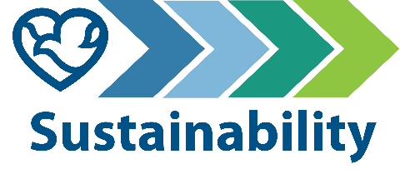
825 Sustainability Newsletter

The 825 Building Sustainability Ambassador Leadership Team (SALT) is pleased to introduce a new email newsletter for employees who work in the building. on 168th and Pacific in Omaha. Methodist Health System is committed to meeting its 2030 sustainability goals as part of the mission to improve the health of our communities by the way we care, educate and innovate. You can learn more about these goals on Methodist sustainability dashboard.

As a health care provider, Methodist has an obligation to care for not only patients and their families but also future generations. That’s why it has taken several steps in recent years to create a variety of sustainability efforts throughout the system. Whether it’s benchmarking resource use, creating a Sustainability Master Plan or setting goals for the future, Methodist is committed to lessening its impact on the environment.

Methodist has goals in five key areas: Building energy emissions, water consumption, employee engagement in sustainability, waste and recycling, and active commuting. You can read more about each goal and the progress toward it on the sustainability dashboard.

825 Building updates
We completed our first observational waste audit in January with a goal of better understanding how waste is sorted throughout the building. The results are still being evaluated, but some initial insights are listed below.

- In the kitchenettes around the building, there are many compostable items found in landfill containers. This is not the case in the 825 Café, where compost bins are accessible.

- Many bins around the building are often less than 25% full throughout the day.

- Our compostable Coke cups are often incorrectly placed in recycling when compost bins are not easily accessible.

- A lot of paper ends up in landfill bins. This paper should be diverted into the DataShield bins for shredding and recycling.

You may have noticed the change in flatware offered at the 825 Building over the past several months. The previous black flatware was made of unrecyclable plastic. Given the amount of disposable flatware that’s used and thrown away on a daily basis, the Food and Nutrition Services team deemed it a net-positive to source and stock compostable flatware in the 825 Café. If you don’t have your own reusable flatware, make sure to put these new flatware items in the compost bins in the cafe when you’re done using them. Don’t forget that the disposable Coke cups, lids and straws are compostable but not recyclable. Napkins and paper towels can also be composted.

Note: The term compostable is used to describe a product that can disintegrate into nontoxic, natural elements. Noncompostable items like plastic and Styrofoam waste can take from 20 to 500 years to decompose.

The 825 Building is working on returning to a centralized waste plan. Using centralized waste bins instead of personal deskside bins can help increase the amount of waste diverted from the landfill through reductions of use, composting or recycling. Click here for more information.

Coming soon: Earth Month/Week/Day! April will be here soon, and with it comes numerous activities around the health system and at the 825 Building. Keep an eye out for email communication on exciting opportunities to get involved.

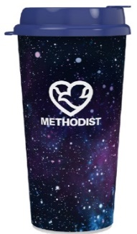
Small tips to make a big impact
- Go for a reusable cup instead of a single-use plastic cup (or compostable Coke cup) as often as you can. It may not seem like much, but each cup kept from the landfill is a win.
- Put all paper waste in the DataShield bins, not just confidential documents. Magazines, mailers, you name it – it can all be put in these bins. DataShield shreds and recycles 100% of the paper collected in its bins.
- Read up about common Omaha recycling myths. Recycling is a confusing topic for everyone, even the experts. There’s also a lot of uncertainty about whether items are actually being recycled. The best way to gain clarity about recycling – either in your home or community – is to get curious and do some research.

Shoutouts
A big thank you to our colleagues who volunteered to help with the waste audit in January. This data will help us better understand where we have opportunities to clarify and educate about waste sorting.

- Stacy Hug, IT Project Management
- Teela Wright, Integrated Services
- Susan Crough, Pre-Surgery
- Chloe O’Ferral, Patient Billing
- Michelle Pham, Patient Billing
- Allison Streff, Organization Development
- Ellie Kirshenbaum, Value Analysis (Sustainability Leadership Team)
- Jasmine Howe, Pre-Surgery (Sustainability Leadership Team)
- Rollie Hardies, Operational Innovation (Sustainability Leadership Team)
- Ashley Oetken, Health Information Management (Sustainability Leadership Team)
- Savannah Kittleson, Marketing (Sustainability Leadership Team)
- Emily Paxton, Human Resources (Sustainability Leadership Team)

Help us acknowledge those doing their part
If you know of a coworker, team or department taking action to help Methodist meet its sustainability goals, let us know by emailing nmhs.sustainability@nmhs.org. Photos are welcome!

Participate as a sustainability ambassador
If you’d like to be made aware of future events, educational sessions and opportunities to volunteer, become a sustainability ambassador by emailing nmhs.sustainability@nmhs.org.

Invite a SALT leader to your team meeting
If you’d like to have someone from the SALT speak to your team about sustainability efforts at 825, email emily.paxton@nmhs.org.

